1.
Draw a simple network diagram showing two routers connected over a WAN link and label where authentication is needed to prevent unauthorized access.
>
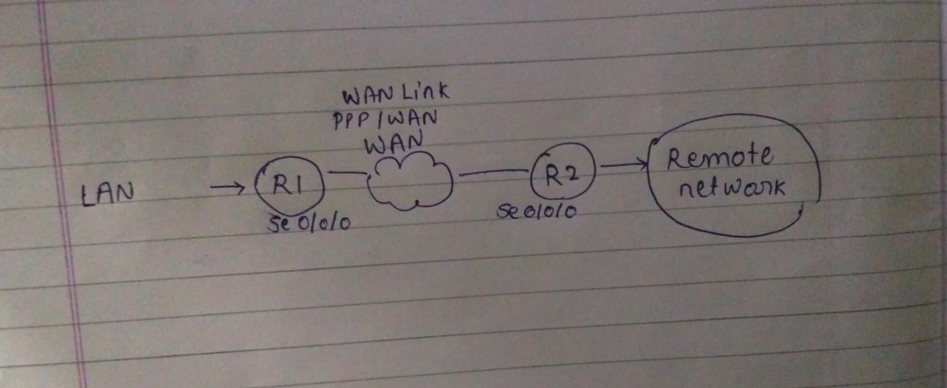
Explanation
- The Vulnerability: The serial or WAN link connecting Router A and Router B is a point of entry. Without verification, a rogue router could connect to the link and intercept or inject malicious traffic.
- The Solution: Authentication happens at the Data Link Layer (Layer 2) interface points on both routers before IP traffic is allowed to pass.

2.
Configure a sample HDLC WAN connection between two routers using Packet Tracer or any network simulator, and explain why HDLC does not provide authentication.<br><br><em><strong>Hint:</strong> Focus on the commands used and what is missing in terms of security.</em>
>
Requirement: Configure a sample HDLC WAN connection between two routers using Packet Tracer, explain why HDLC does not provide authentication, focus on commands, and identify what is missing in terms of security.
Configuration Commands (Cisco CLI)
On Router A:
RouterA(config)# interface Serial 0/0/0
RouterA(config-if)# ip address 10.0.0.1 255.255.255.252
RouterA(config-if)# encapsulation hdlc
RouterA(config-if)# clock rate 64000 (Only needed on the DCE side)
RouterA(config-if)# no shutdown
On Router B:
RouterB(config)# interface Serial 0/0/0
RouterB(config-if)# ip address 10.0.0.2 255.255.255.252
RouterB(config-if)# encapsulation hdlc
RouterB(config-if)# no shutdown
Why HDLC Fails to Provide Authentication & Security Gaps
- No Authentication Mechanism: The standard High-Level Data Link Control (HDLC) protocol framing structure simply does not have a field or protocol handshake phase for exchanging usernames and passwords.
- Security Gap: It assumes a dedicated, physically secure point-to-point line. If an unauthorized attacker gains physical or logical access to the wire, they can instantly establish a connection without providing credentials.

3.
Set up a PPP connection between two routers in Packet Tracer and enable PAP (Password Authentication Protocol) authentication. Show the configuration commands and explain what happens if the password is incorrect.
>Set up a PPP connection between two routers in Packet Tracer and enable PAP. Show configuration commands and explain what happens if the password is incorrect.
Configuration Commands
On Router A:
RouterA(config)# username RouterB password MySecretPassword
RouterA(config)# interface Serial 0/0/0
RouterA(config-if)# encapsulation ppp
RouterA(config-if)# ppp authentication pap
RouterA(config-if)# ppp pap sent-username RouterA password MySecretPassword
On Router B:
RouterB(config)# username RouterA password MySecretPassword
RouterB(config)# interface Serial 0/0/0
RouterB(config-if)# encapsulation ppp
RouterB(config-if)# ppp authentication pap
RouterB(config-if)# ppp pap sent-username RouterB password MySecretPassword
If the password mismatches, the PAP authentication phase will fail.
- The line protocol status will drop to "down" (e.g., Serial0/0/0 is up, line protocol is down).
- No IP traffic (Layer 3) will route across the interface, completely blocking data transfer.

4.
Modify your PPP configuration to use CHAP (Challenge Handshake Authentication Protocol) instead of PAP, and describe one key difference in how CHAP improves security over PAP.
>
Requirement: Modify PPP configuration to use CHAP instead of PAP. Describe one key difference in how CHAP improves security over PAP.
Configuration Commands
On Router A:
RouterA(config)# username RouterB password MySecretPassword
RouterA(config)# interface Serial 0/0/0
RouterA(config-if)# ppp authentication chap
On Router B:
RouterB(config)# username RouterA password MySecretPassword
RouterB(config)# interface Serial 0/0/0
RouterB(config-if)# ppp authentication chap
• PAP (Password Authentication Protocol): Sends the password across the WAN link in clear, unencrypted plaintext. Anyone sniffing the line can read it instantly.
• CHAP (Challenge Handshake Authentication Protocol): Never sends the password over the link. Instead, it uses a three-way handshake involving a random challenge string and an MD5 hash function. This prevents eavesdroppers from capturing the password.

5.
Research and list two real-world scenarios (such as public WiFi login or mobile data authentication) where WAN authentication protocols like PAP, CHAP, or MS-CHAP are used, and explain why authentication is critical in each case.
>
: Research and list two real-world scenarios where WAN authentication protocols (PAP, CHAP, MS-CHAP) are used, and explain why authentication is critical.
Scenario 1: Broadband Internet Connections (PPPoE / DSL)
- Application: Internet Service Providers (ISPs) often use Point-to-Point Protocol over Ethernet (PPPoE) using CHAP or MS-CHAP when assigning connections to home routers.
- Why it is critical: It serves as a gatekeeper for access control and billing. The ISP uses it to verify that the connecting user is an active, paying subscriber before granting an IP address and routing their internet traffic.
Scenario 2: Corporate VPN Connections (Remote Access)
- Application: Dial-up legacy links or modern virtual private networks (VPNs) using protocols like L2TP often wrap PPP packets using MS-CHAPv2 inside the secure tunnel.
- Why it is critical: It ensures that remote employees connecting over an untrusted, public internet connection are genuinely authenticated corporate users before granting them access to sensitive internal servers, files, and databases.

